Use case Create customer Profile: Simple
First cut design class diagram:
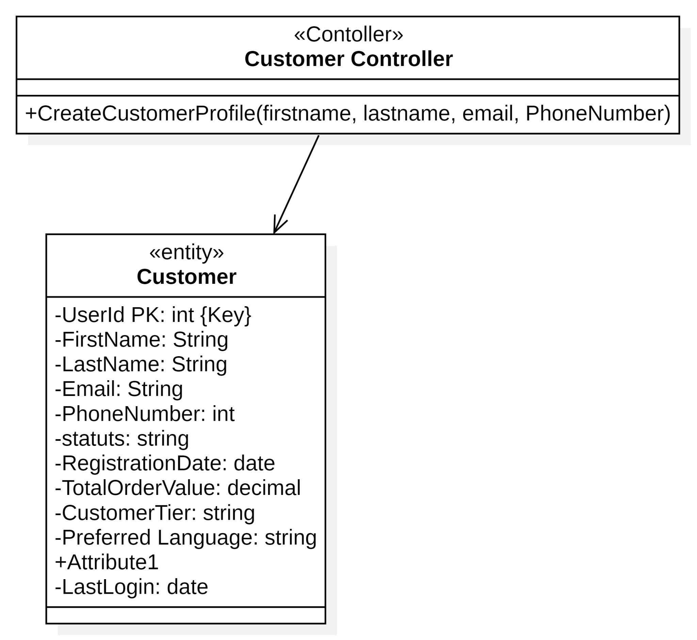
CRC:
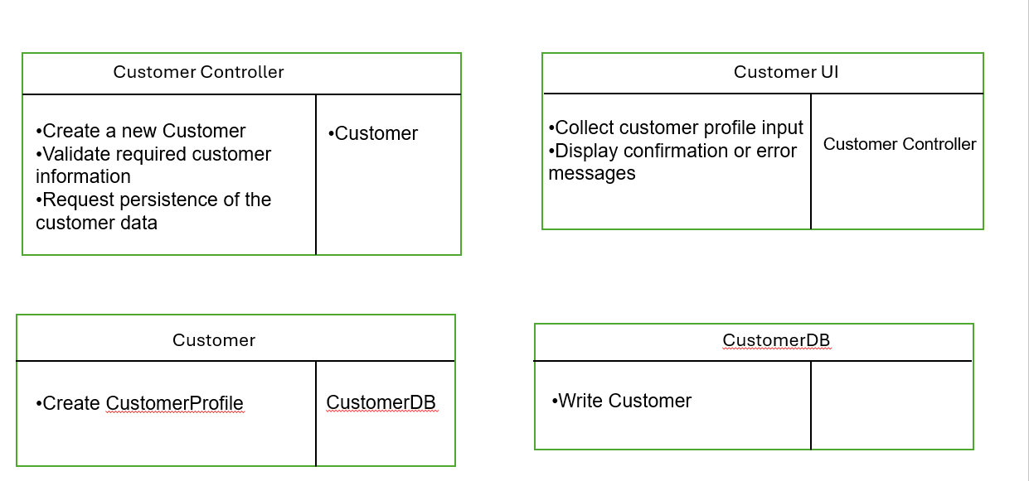

Final Design class Digram:
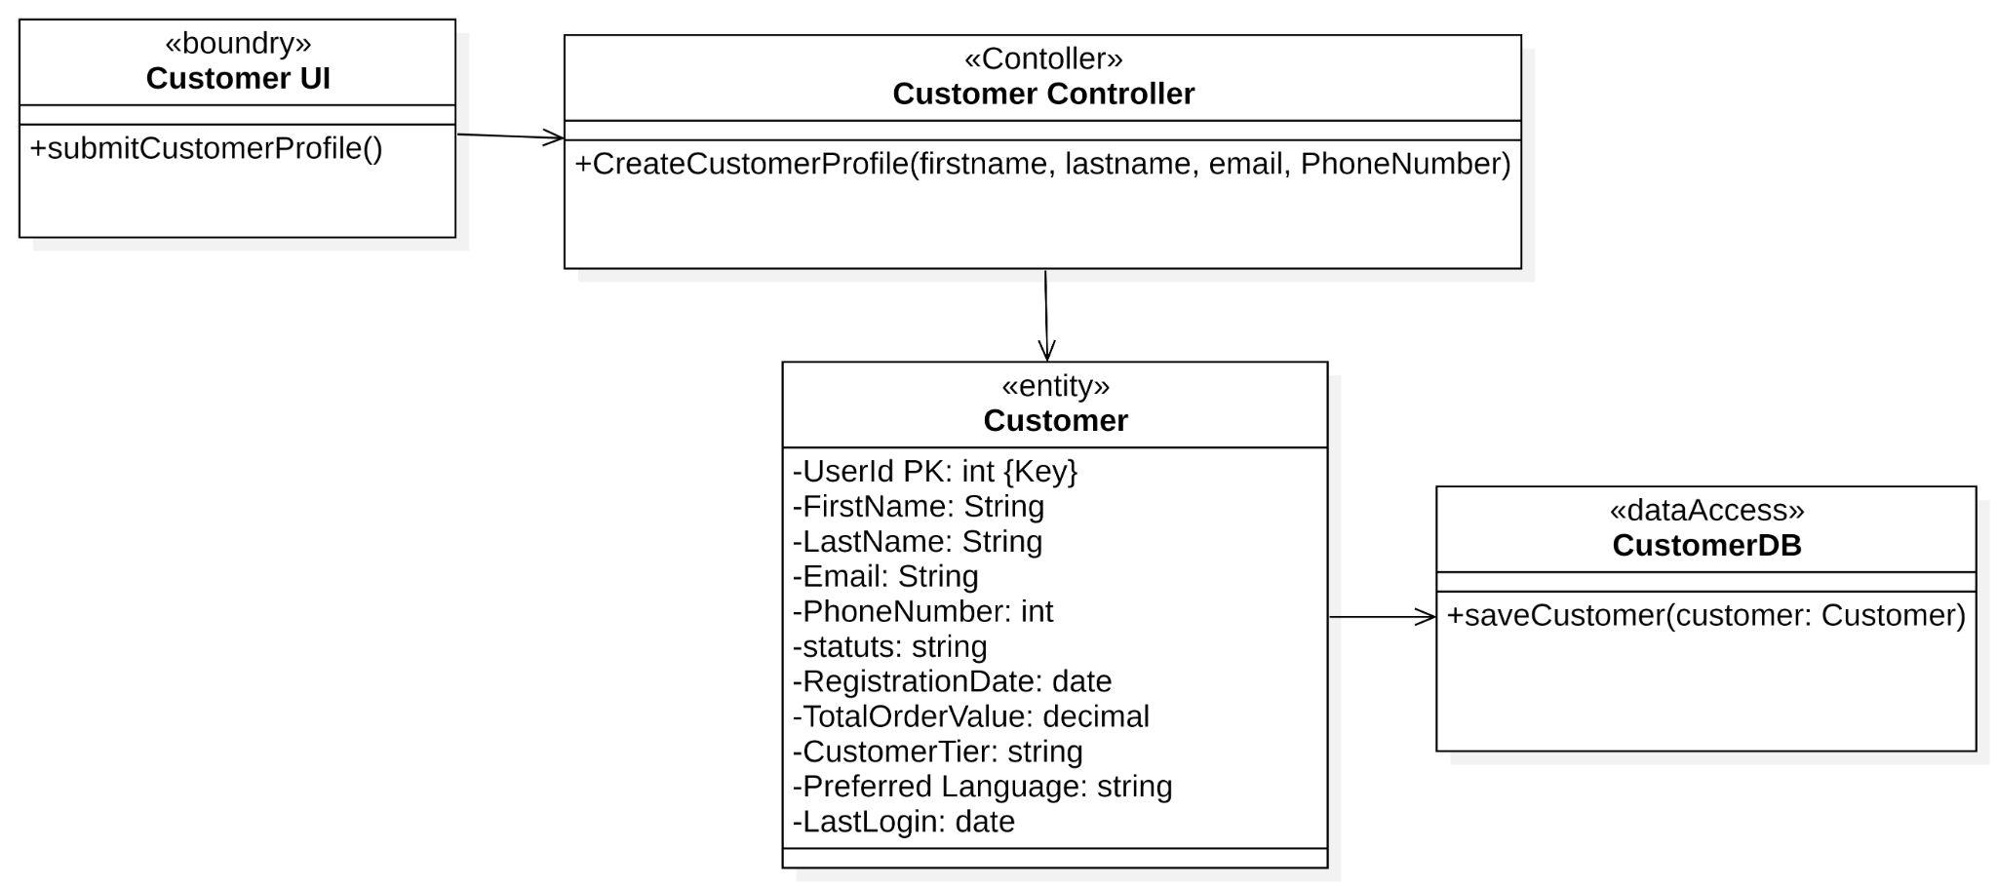

Use Case: Retrieve Customer Information :Moderate
first Cut Design Class diagram:
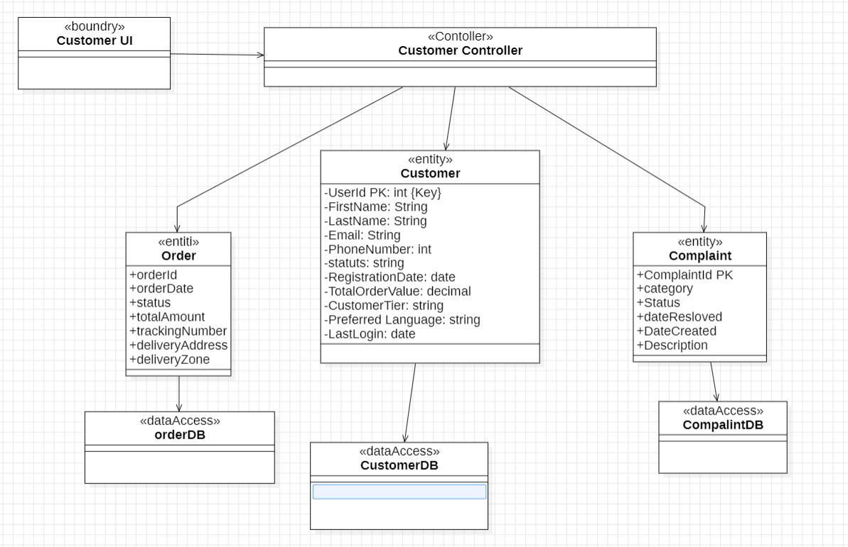

rrrrrrrrrrrrrrrrrrrrrrrrrrrrrrrrrrrrrrrrr
Communication Diagram:

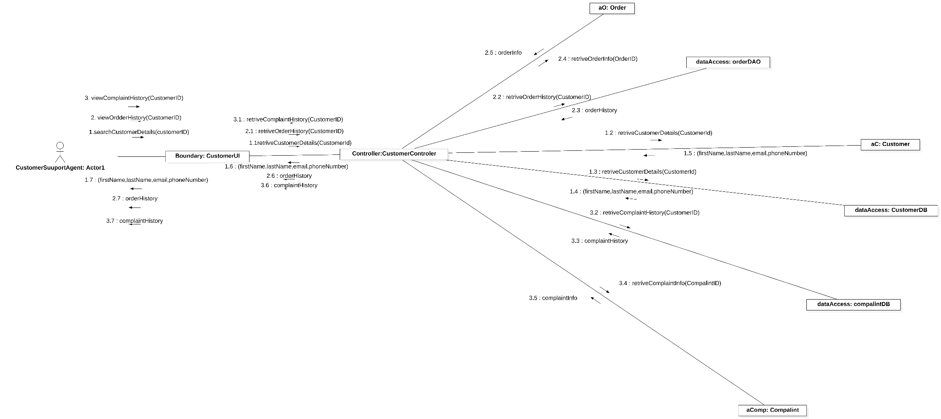

Final design Diagram:

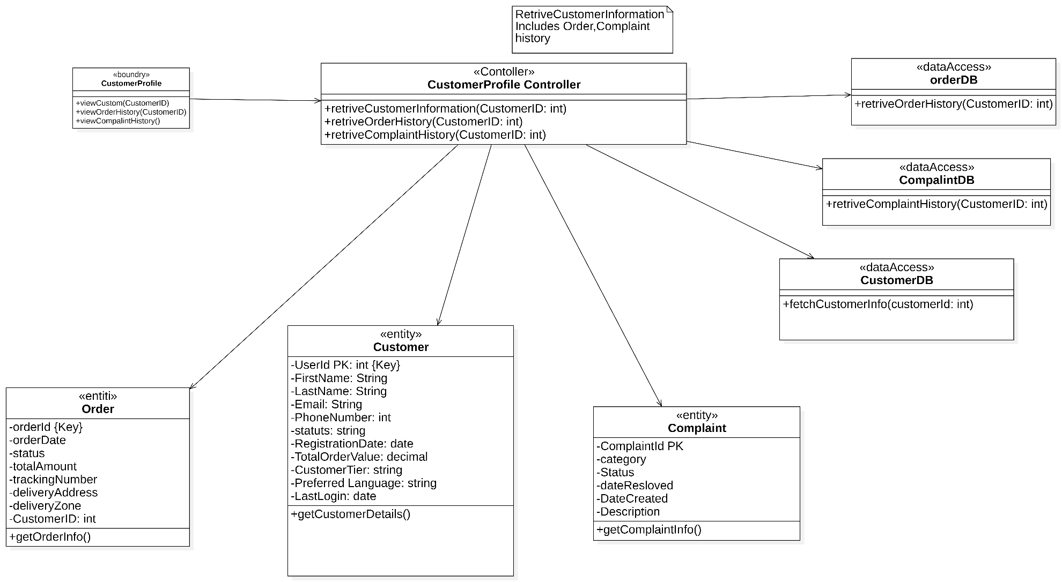

Update customer status:

First cut edge:

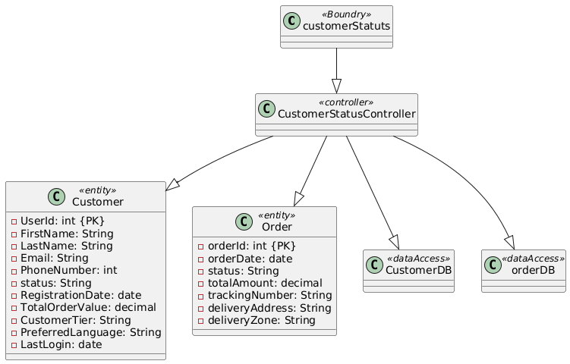

Multi layer sequence diagram:
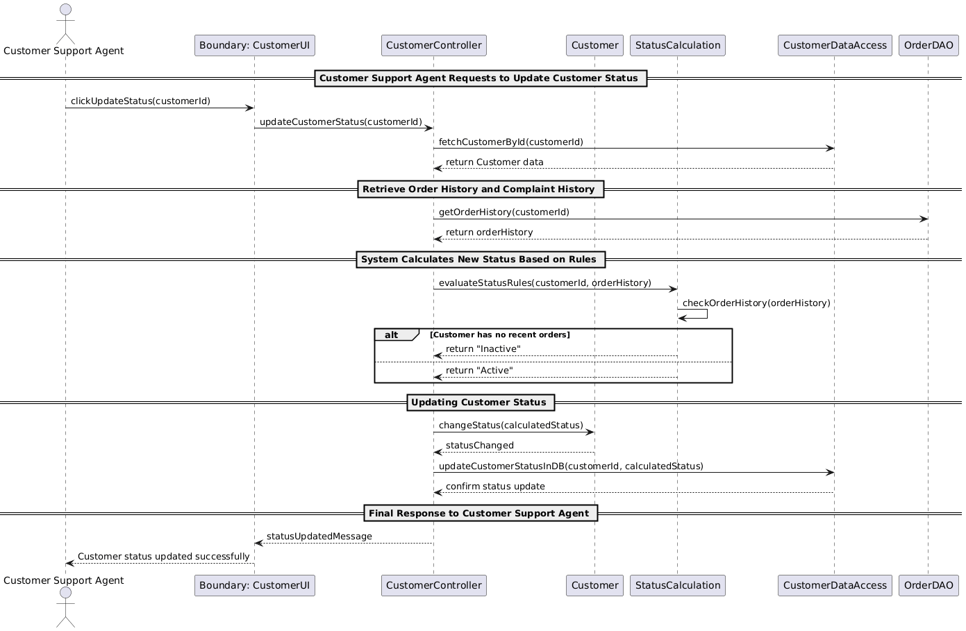

Final design :
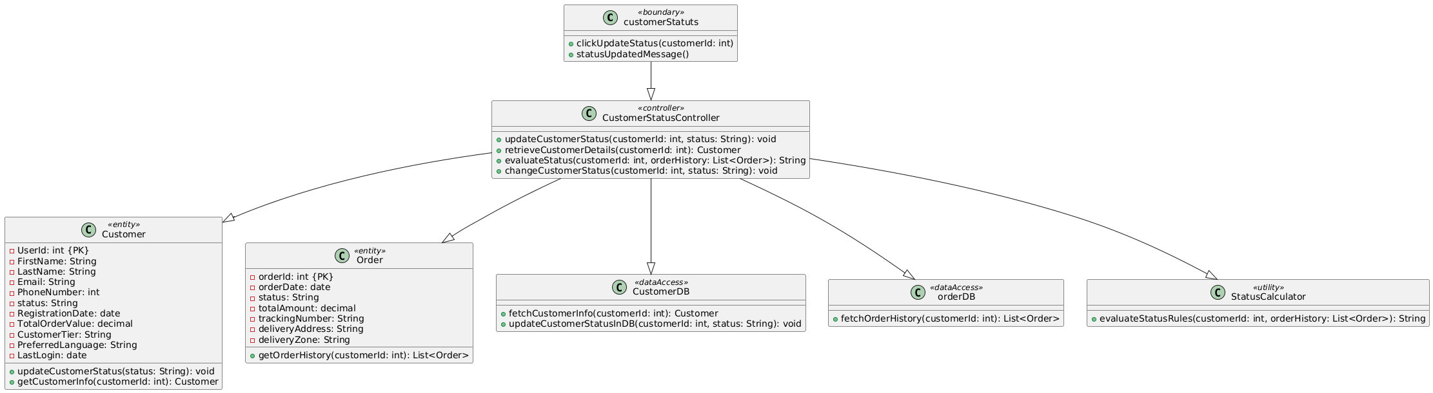

Use Case 1: Create Complaint Record(Simple)

- First-Cut DCD Before CRC:
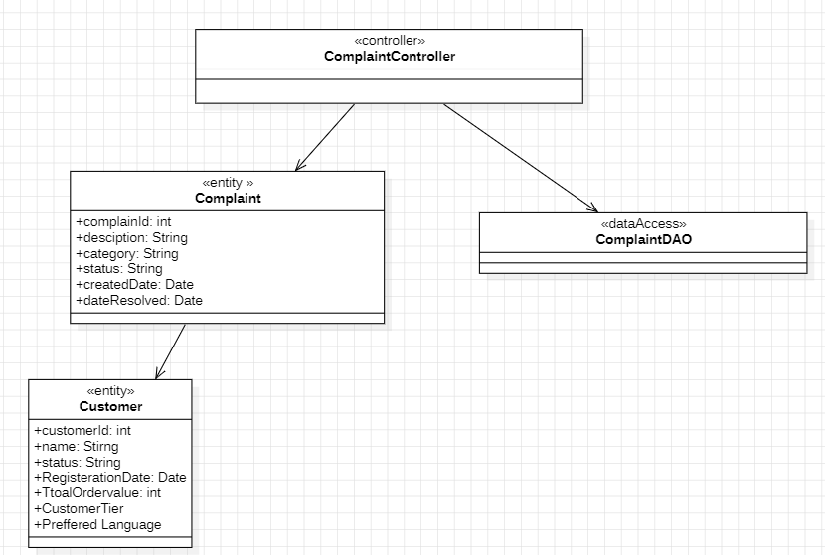

CRCs for create complaint record:
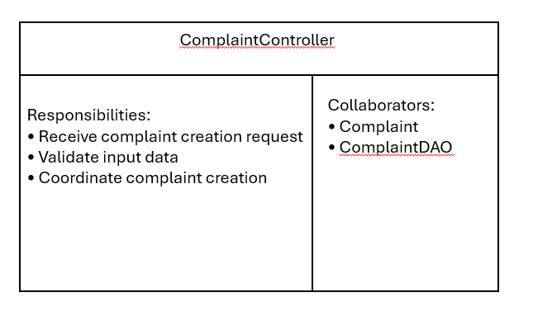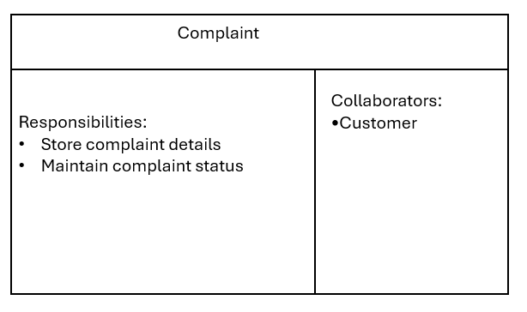

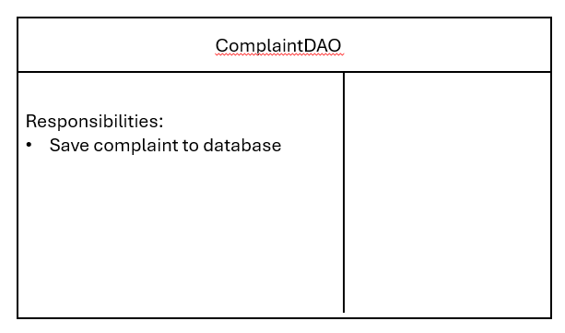

DCD After CRC:
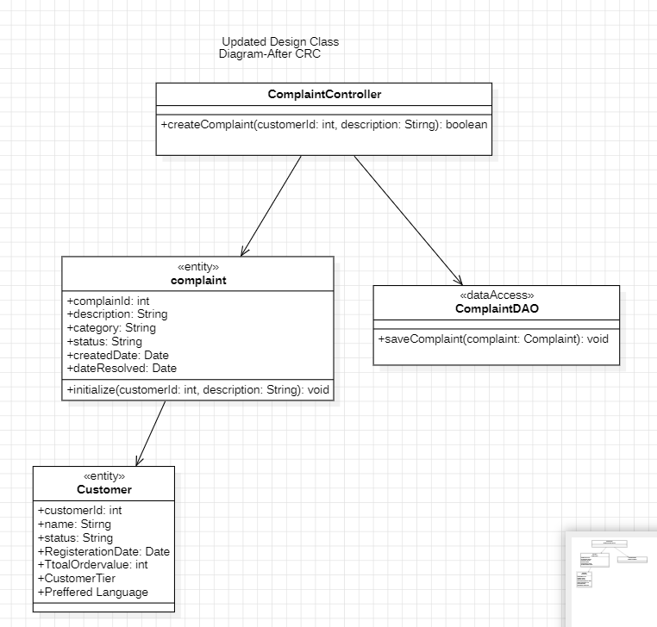

Use Case 2: Resolve Customer Complaint(Moderate)

- First-Cut DCD before communication Diagram:
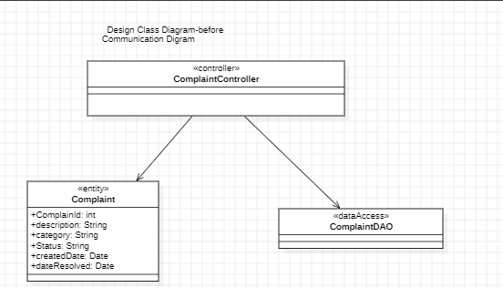

Communication Diagram:

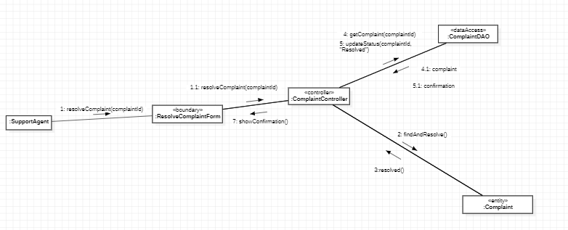

DCD after communication Diagram:
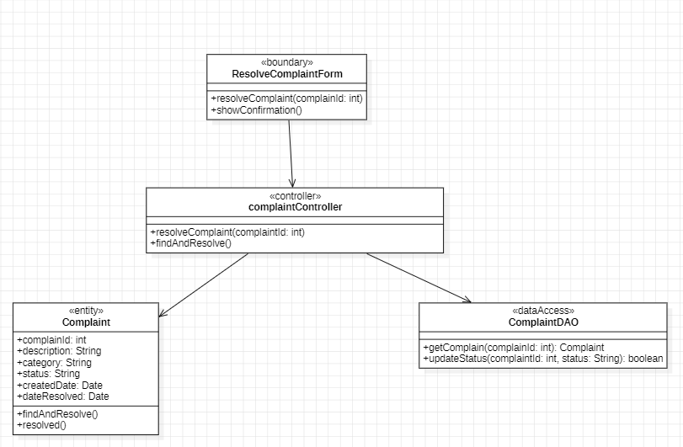

Use Case 3:Escalate Unresolved Complaint (complex):
- First-Cut DCD before Sequence Diagram:
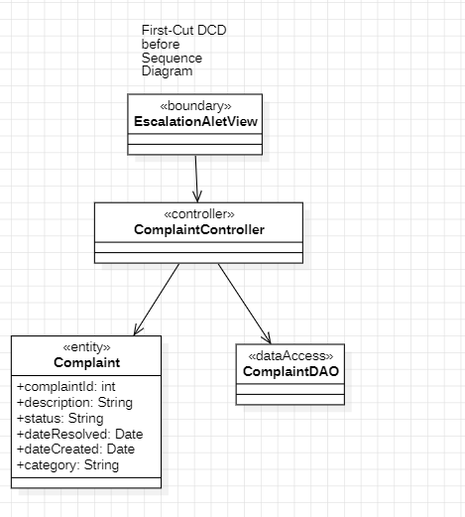

Sequence Digram:
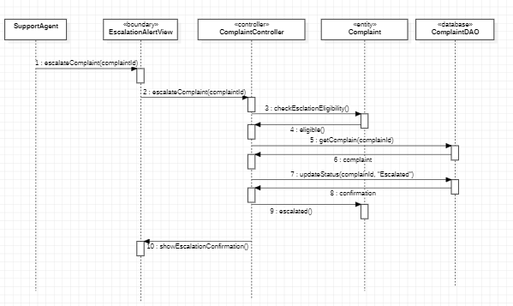

DCD after Sequence Diagram:
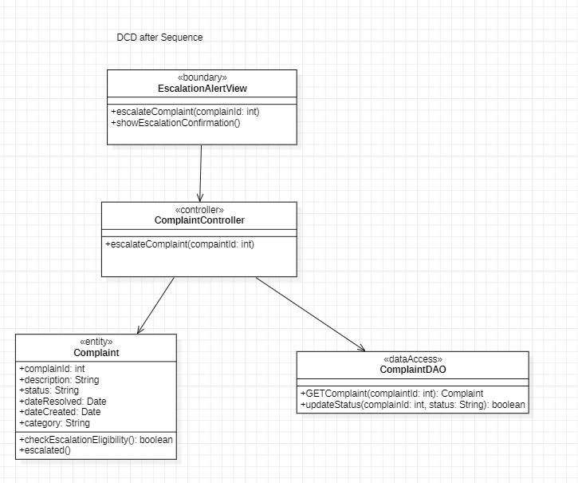

Use case :Send Message To customer:
First DCD:

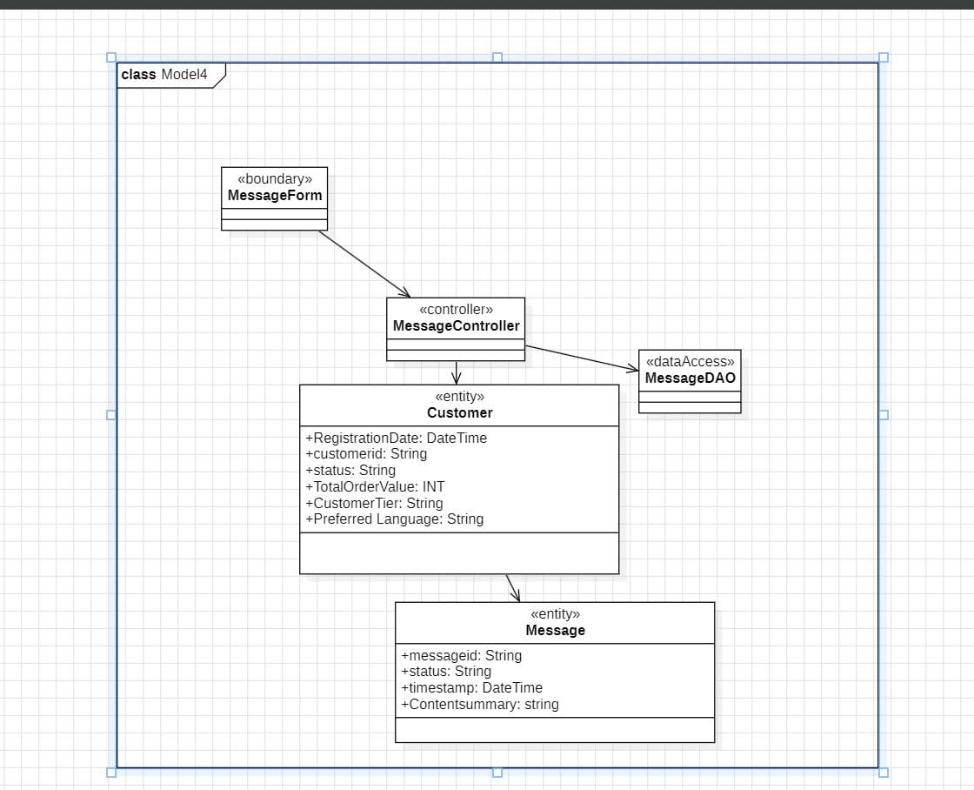

CRC Card: MessageController
Class | Responsibilities | Collaborators
MessageController | • Accept send message request  • Validate message content  • Delegate message creation and persistence | Customer, Message, MessageDAO

CRC Card: Message
Class | Responsibilities | Collaborators
Message | • Store message content  • Timestamp the message  • Link message to the corresponding customer | Customer

CRC Card: Customer
Class | Responsibilities | Collaborators
Customer | • Maintain customer profile  • Maintain customer message history | Message

CRC Card: MessageDAO
Class | Responsibilities | Collaborators
MessageDAO | • Save message to the database  • Retrieve message history for a customer

FINAL DCD
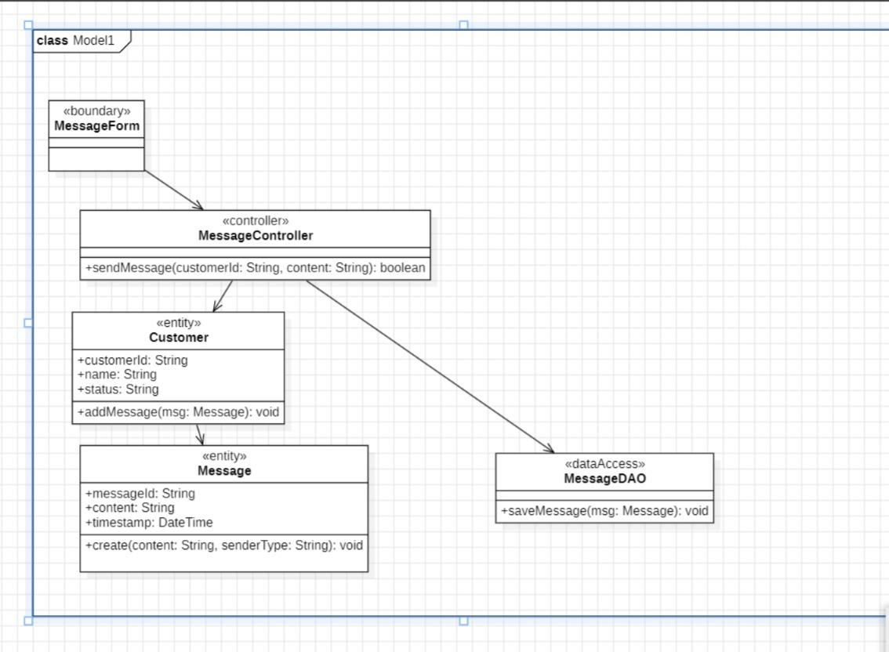

Use Case: Receive and route customer Message
FIRST CUT DCD

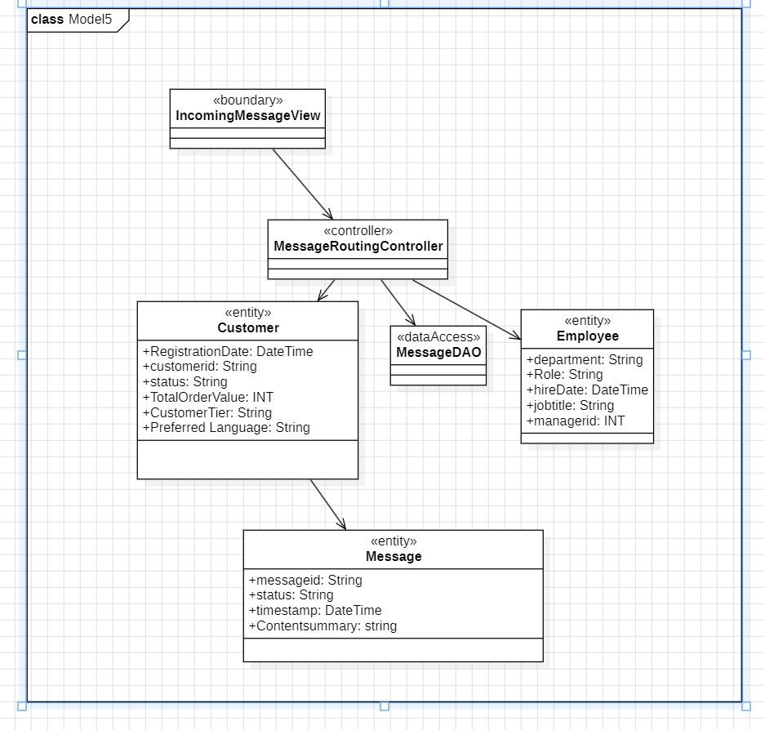

COMMUNICATION DIAGRAM

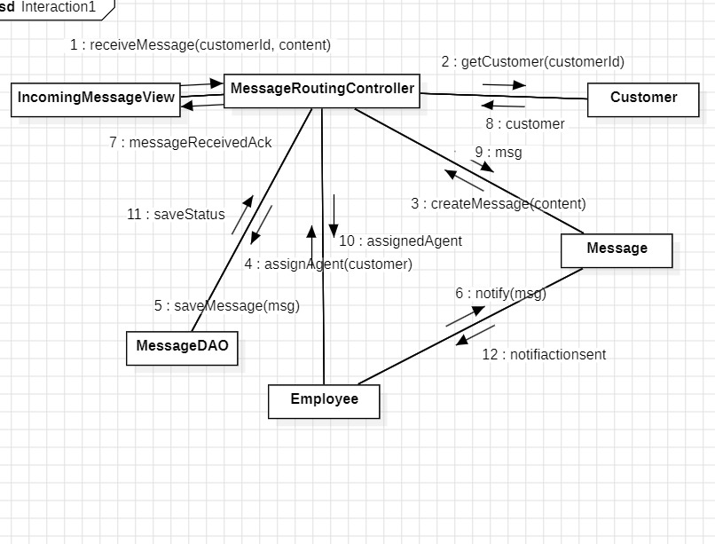

FINAL DCD
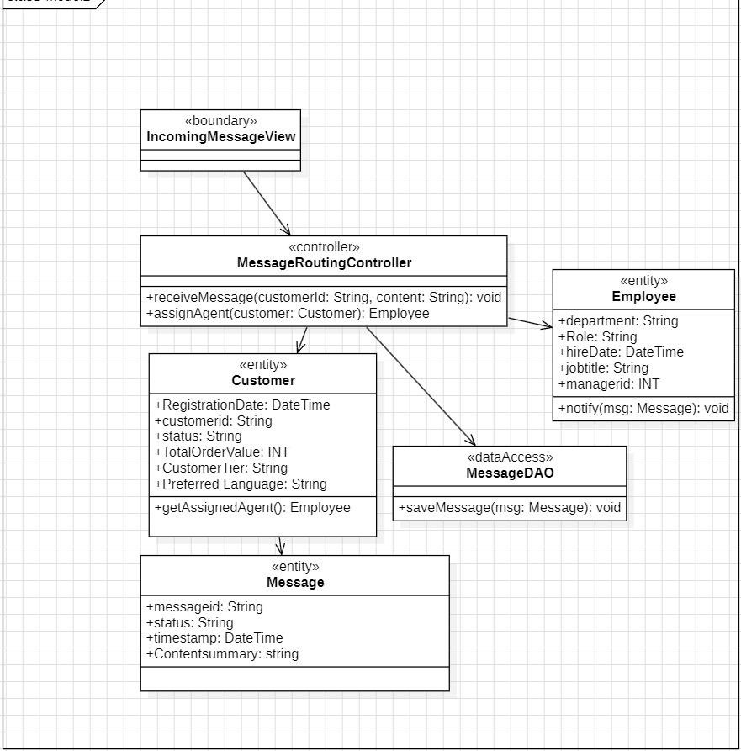

Use Case: Generate Active Customer Report
FIRST CUT DCD
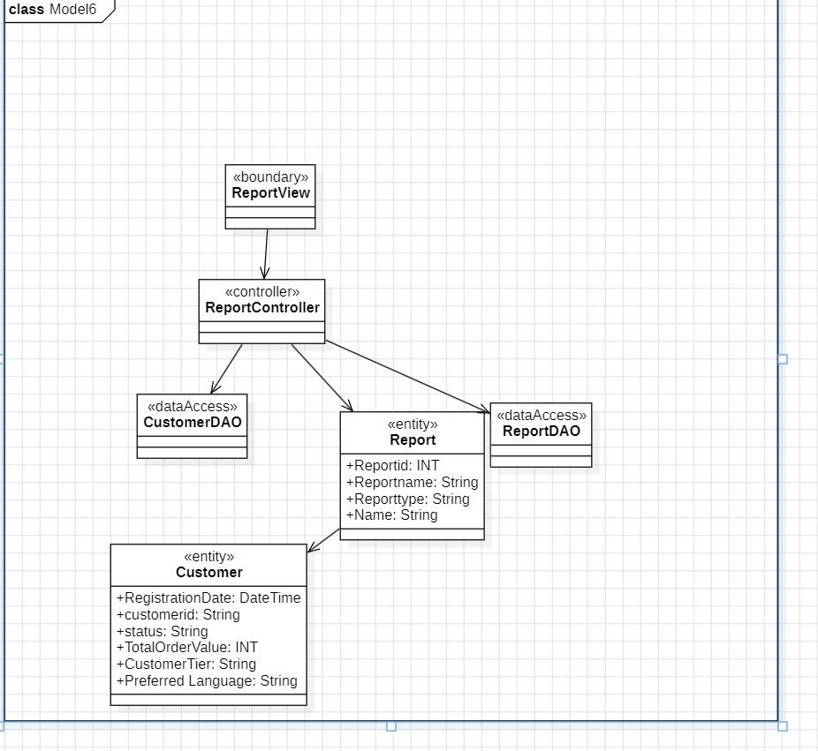

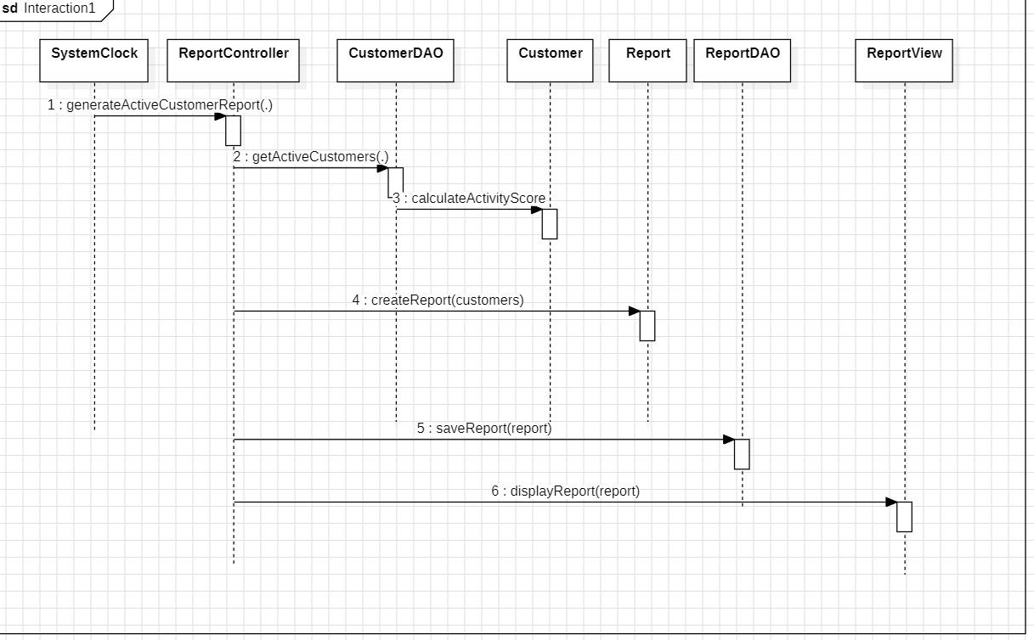
SEQUENCE DIAGRAM

FINAL DCD

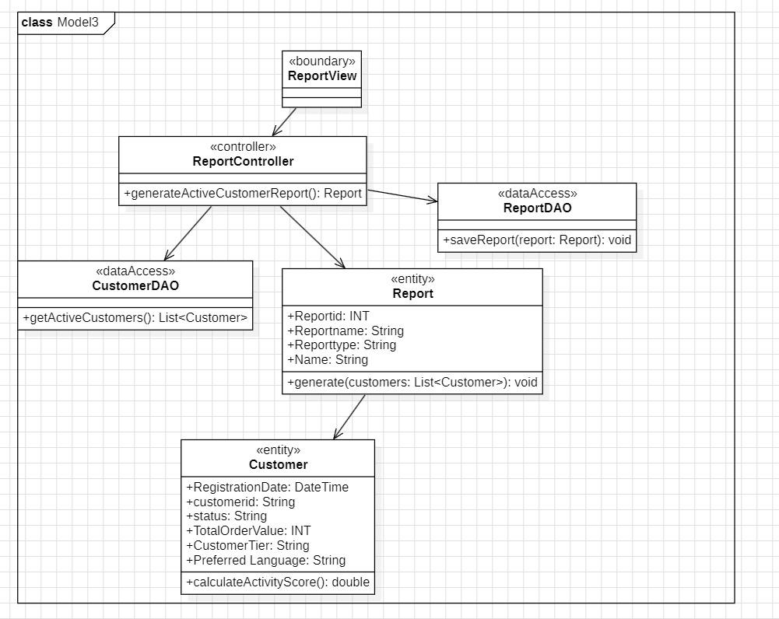

Update customer profile - first cut
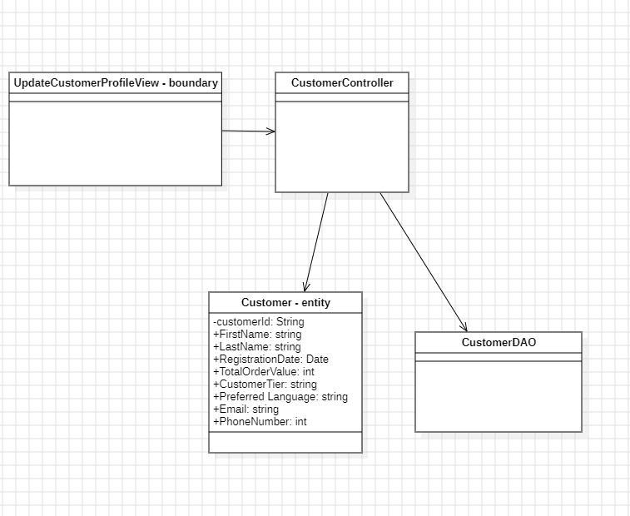

CRC:

Customer
Hold customer data
Apply profile updates

CustomerDAO

Customer DAO
Retrieve customer
Persist updates

Customer

Customer Controller
Receive update request
Validate input
Delegate update

Customer
CustomerDAO

DCD - final
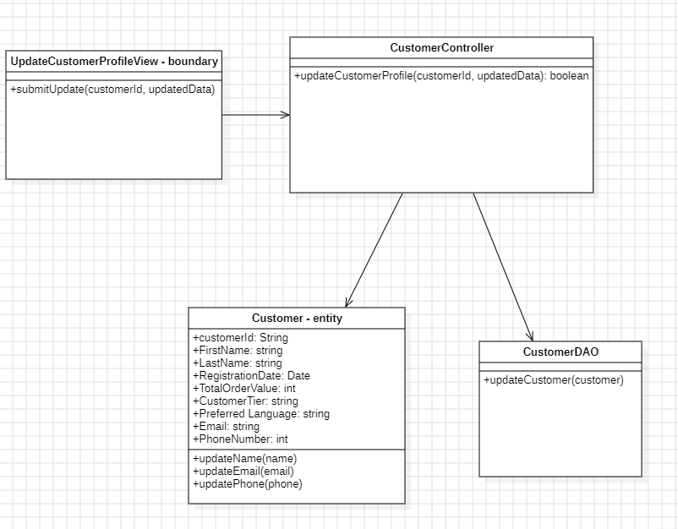

Generate customer summary
First cut
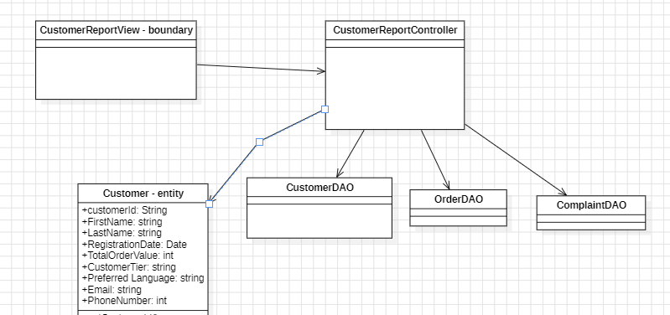

Communication diagram

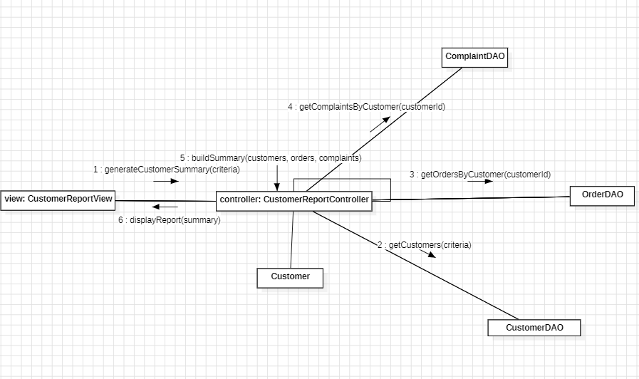

Final cut
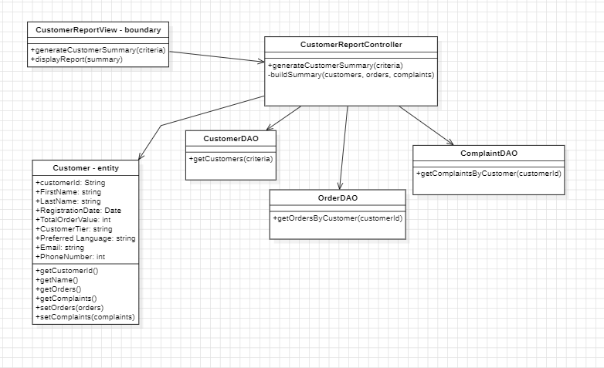

Generate Customer Segmentation Analysis
First cut
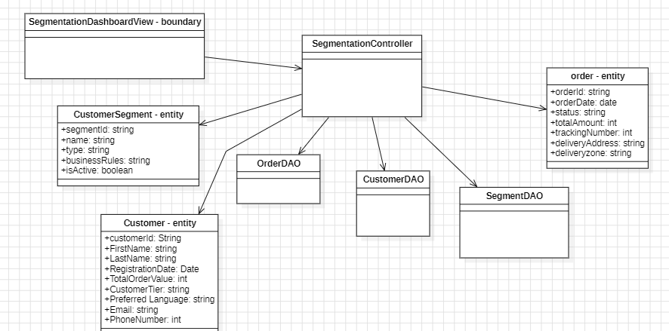

Sequence diagram:
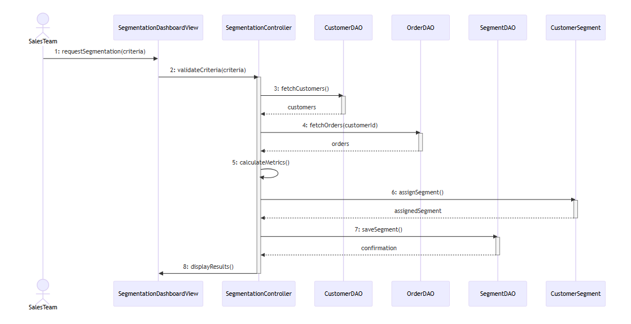

Final cut
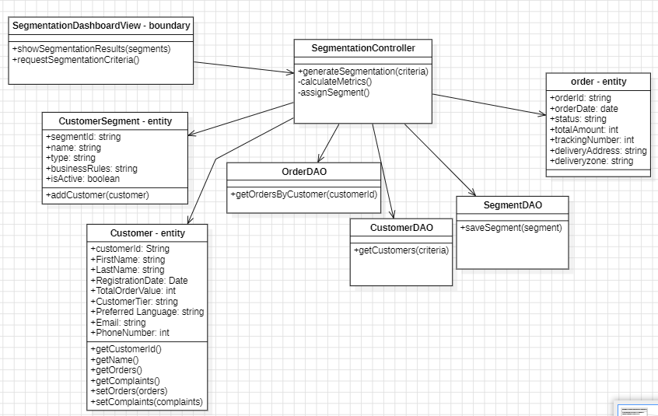

Final Design Diagram: will be in the zip file dues to the resolution issues

Package Diagram:

